THIS PREPARED

SHARON S. VANDER WULP

CERTIFICATE OF RONDMENT ATTORNEY AT LAW

# P.O. BOX 1767

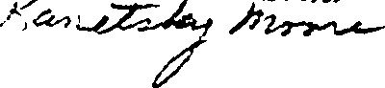VENICE FLO DA342W17S7 no THE

DECLARATION OF CONDOMINIUM

# OF

## AVENUE CONDOMINIUM. CONDOMINIUM

VENICE AVENUE CONDOMINIUM ASSOCIATION, INC. , its address

being 512 W. Venice Avenue, Venice 34285, Sarasota County, Florida, by the hands of the undersigned hereby certify that:

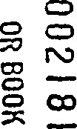The Declaration of condominium of VENICE AVENUE CONDOMINIUM, A CONDOMINIUM is recorded in O.R. Book 1282, page 129, et seq., of the Public Records of Sarasota County, Florida. The following amendment to the Declaration of Condominium were then submitted to the entire membership of the Association ae its meeting called and held on the 13th day of January, 1990, and approved by affirmative vote in excess of seventy—five percent (75%) of the membership present and voting as required by the Declaration of Condominium.

1. Article WII, Restrictions, Paragraph (A) (12) is

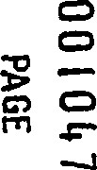hereby amended to read as follows:

12. No children are permitted as permanent Res idents.

This housing facility for older persons. to the exemption to the

Hqqsinq of 1989, no one occupy a unit unless at least one (l) occupant years of aqe or older. Hewevev. at the discretion of the Boate of Pi rectors up eo of units the association be

|  |  |
| --- | --- |
| occupied bv persons between the | of 18 |

54. The Board of Directors shall h4ve the authority to adopt rules regulations to enforce is amendment including but not to the right to veqive potential occupants eo provi<e proof of their aqe qpon Boarq reqest. The Board of pirectors reserves the right to deny occupanqy to any person where suqh occupancv WOUI< cause the associ#ion not to qualify as housing for older persons uneev Federal Law.

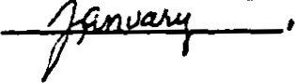IN wiTNEss mmEOF, said Association has caused this Certificate to be signed in its name by its President, this day of1990.

ATTEST:VENICE AVENUE CONDOMINIUM ASSOCIATION, INC.

By: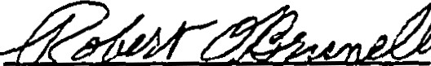



Secretary

Pres dent

WITNESSES :

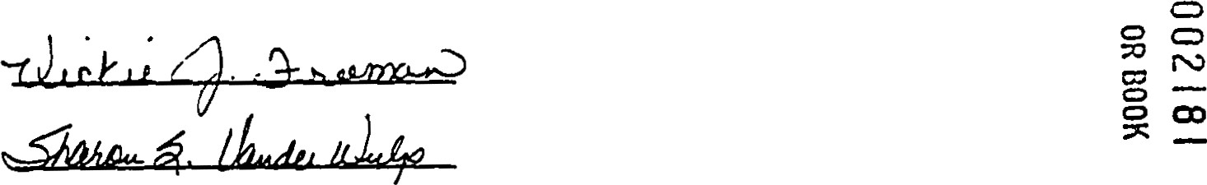

## STATE OF FLORIDA

COUNTY OF SARASOTA

|  |
| --- |
| NoGty Public, Commission |

1 HEREBY CERTIFY that on this day before me, a Notary Public in and for the State of Florida at large, personally appeared ROBERT O. BRUNELLE, as President and G. scom, as secretary, of VENICE AVENUE CONDOMINIUM ASSOCIATION, INC. , and they acknowledge before me that they are such officers of said corporation; and they executed the foregoing Certificate of of Declaration of Condominium on behalf of said corporation, and affixed corporation; that they are authorized of Amendment of Declaration of Condominium thereof is the free act and

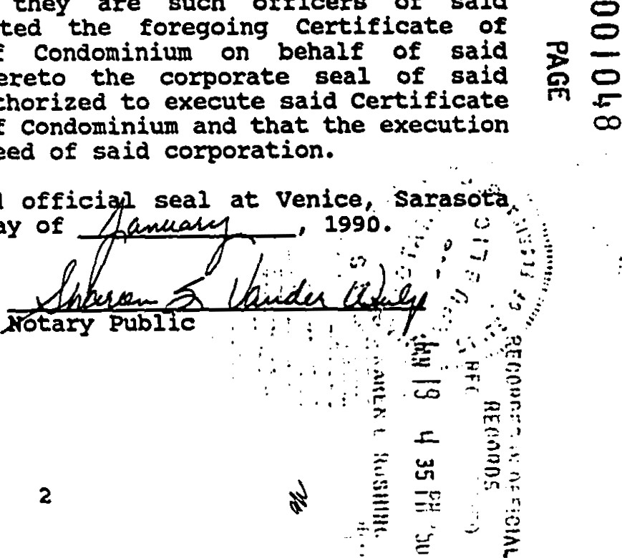

thereto

deed

day

WITNESS my hand and offici County, Florida this

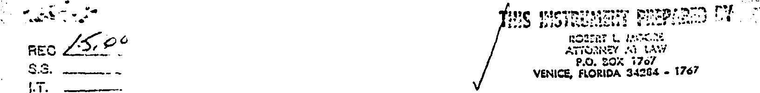

My Commission Expires:

 State of Florida at Larga

Expires Dec. 3, 1990

CERTIFICATE OF AMENDMENT 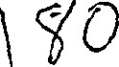

DECLARATION OF CONDOMINIUM

OF

CONPQMZNXVM

VENICE AVENUE CONDOMINIUM ASSOCIATION, INC. , its address

being 512 W. Venice Avenue, Venice 34285, Sarasota County, Florida by the hands of the undersigned hereby certify that:

The Declaration of condominium of VENICE AVENUE CONDOMINIUM, A CONDOMINIUM is recorded in O. R. Book 1282, Page 129, et seq. , of the Public Records of Sarasota county, Florida.

WHEREAS, the Declaration of Condominium was amended to change the percentage of the ownership of the common elements and share of the common expenses and surplus for each unit, as evidenced by Certificate of Amendment recorded in O. R. Book 2072, Pages 1365 1367, of the Public Records of Sarasota County,

Florida; and

WHEREAS, said Amendment was not adopted by 100* of the unit owners and was not executed by the record owners of all the units and the record owners of liens on ail the units as required by Section 718. IiO (4) Florida Statutes; and

WHEREAS, the Association wishes to correct the record as concerns this amendment;

THEREFORE, the Amendment purporting to change each units percentage of ownership in the common elements and share of the common expenses and surplus is invalid and void and the correct percentage of each units percentage share of the common elements and share of the common expenses and surplus is as listed in the Declaration of Condominium as originally recorded and in particular as shown on Exhibit t' c" of said Declaration of Condominium. Said Exhibit "C" was recorded in Official Record Book 1282, Page 151, of the Public Records of Sarasota County, Florida and is attached hereto.

1

IN wrrnss WHEREOF, said Association has caused this Certificate to be signed in its name by its President, this 30 day of January, 1991.

VENICE AVENUE CONDOMINIUM

WITNESSES :

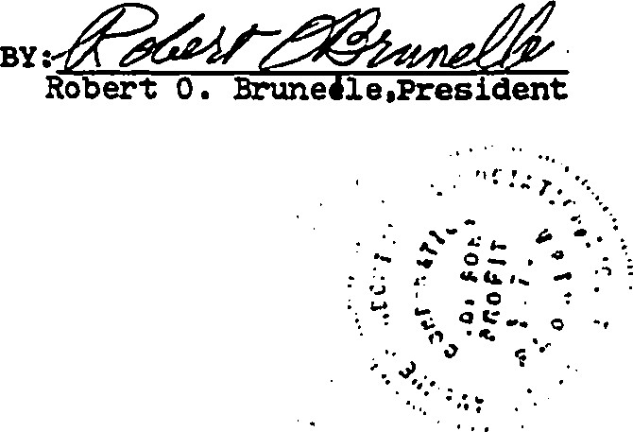

ASSOCIATION

,

INC.

STRATE OF PIDRIDA

COUNTY OF SARASOTA

(JON(NE ELIOPOULOS )

1 HEREBY CERTIFY that on this day before me, a Notary Public in and for the State of Florida ae large, personally appeared ROBERT O. BRUNELLE, as President and  z. gum, as secretary, of VENICE AVENUE CONDOMINIUM ASSOCIATION, INC. , and they acknowledge before me that they are such officers of said corporation; and they executed the foregoing Certificate of Amendment of Declaration of Condominium on behalf of said corporation, and affixed thereto the corporate seal of said corporation; that they are authorized to execute said Certificate of Amendment of Declaration of Condominium and that the execution thereof is the free act and deed of said corporation.

WITNESS my hand and official seal at Venice, Sarasota County, Florida this 3 day of January, 1991.

My Commission Expires:

sure or nom".

COURS810N DEC. •a. tns.

2

151

UNDIVIDED PERCENTAGE op OWNERSHIP OP COMMON ELEMENTS AND PERCENTAGE SHARE or COkNON EXPENSES AND SURPLUS

FOR EACH UNIT

|  |  |  |  |
| --- | --- | --- | --- |
|  | ship of |  | ship of  Coxmnon |
| Ape. No. | Elements | Apt. No. | Elements |

of Owner-of

102

103

104501

106

108

201506

508

601 602

206

608

306

308

PG 151

EXHIBIT

OF THE DECLARATION op CONDOMINIUM

CERTIFICATE OF AMENDMENT I T.



TO THE

ARTICLES OF INCORPORATION

OF

THE VENICE AVENUE CONDOMINIUM AS.SOCTATTQN, TNC.

THE VENICE AVENUE CONDOMINIUM ASSOCIATION, INC. , its address being 512 West Venice Avenue, Venice, FL 34285, Sarasota County, by the hands of the undersigned hereby certify that:

The Declaration of condominium of VENICE AVENUE CONDOMINItJM, a Condominium is recorded in O. R. Book 1282, page 129, of the Public Records of Sarasota County. Flor ida . The following

amendments to the Articles of Incorporation were submitted to the entire membership of the Association at its meeting called and held on the 4th day of January, 1997, and approved by affirmative vote of of the voting interests present and voting as required by the Articles of Incorporation.

1. Article I is hereby amended to read as follows:

The name of the corporation shall be THE VENICE AVARJE CONDOMINIUM ASSOCIATION, INC. The principal place Of business shall be:

Venice. FL 34285. This corporation is referred to herein as the "Association. •

2 . The first paragraph of Article VI I is hereby amended

to read as follows:

BOARD OF DTRF.CTORS

The affairs of the Association shall be managed by a Board of Directors in a number determined by the Bylaws, but not less than three (3) Directors shall be authorized. In the absence of any determinat ion, the Board shall consist of three (3) Directors . Directors  be members or the snouse of a member of the Association. Members of the Board of Directors shall be elected at the annual membership meeting , hold office, and be removed and replaced in the manner provided by the Bylaws.

3 . The second paragraph of Article VI I is hereby amended by deleting same in its entirety, as it is no longer applicable, as it contained rights reserved to Developer.

'Substantial rewording of Articles of Incorporation. See Article VI I, second paragraph for present text . 

1

Article IX is hereby amended to read as fol lows:

manner provided for in the

Article XI, Section 3, is hereby amended to read as

follows:

The Association shall have the power to purchase an apartment in the condominium, as provided in Chapter 718.reserved in the Dec laration of

1997 .

ATTEST: THE VENICE AVENUE CONDOMINIUM ASSOCIATION, INC.

STATE OF FLORIDA

COUNTY OF SARASOTA

1 HEREBY CERTIFY that on this day before me, a Notary Public in and for th State of Florida at large. personally

a peared „.u..,-e as President and

as secretary, of THE VENICE AVENUE NDOMINIUM ASSO IATION, INC., and they acknowledged before me that they are such officers of said corporation; and they executed the foregoing certificate of Amendment to the Articles of Incorporation on behalf of said corporation, and aff ixed thereto the corporate seal of said corporation; that they are authorized to execute said Certificate of A.mendment to the Articles of Incorporation and that the execution thereof is the free act and deed of said corporation. They are personally known to me or have produced their driver's licenses as identification and did not take an oath.

WITNESS my hand and offi •al seal at Venice, Sarasota County, Florida this  day of 1997 .

CERTIFICATE OF AMENDMENT LT.



TO THE

BYLAWS

THE AVENUE CONDOMTNTVM ASSOCIATION. INC.

THE VENICE AVENUE CONDOMINIUM ASSOCIATION, INC. , its address being 512 West Venice Avenue, Venice, FL 34285, Sarasota County, by the hands of the undersigned hereby certify that:

The Declaration of condominium of VENICE AV2,iUE CONDOMINItJN, a Condominium is recorded in O. R. Book 1282, page 129, of the Public Records of Sarasota County, Flor ida . The following

amendments to the Bylaws were submitted to the entire membership of

the Association at its meeting called and held on the 4th day of January, 1997, and approved by affirmative vote of 66 2/3 of the entire Board of Directors and 66 2/3 of the voting interests, or by of the voting interests, as required by the Bylaws.

i. Article Il, Sect ion 9, by deleting same in its

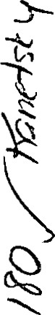entirety, is hereby amended to read as follows:

'Substantial rewording of Bylaw. See Bylaw Article Il, Section 9, for present text.

This amendment would delete rights reserved to Deve loper .

2 . Article Ill, Section 2, to reinstate this provision in the Bylaws as required by the Condominium Act, Section

718.112 (2) F. S. , and to adopt the changes as shown, is hereby

amended to read as follows :

2 . Election of Directors: The Election of Directors shall be conducted in the following manner:

1. Election of Directors shall be held at the annual members' meeting, upon the terms hereinafter provided.
2. A nominating committee of five (5) members shall be appointed by the Board of Directors noe less than thirty (30) days prior to the annual members' meeting. The committee shall nominate one person for each Director then serving. Nominations for additional Directorships created at the meeting shall be made fron the floor, and other nominations may be made from the floor at this time.
3. The election shall be by written ballot (unless dispensed by unanimous consent) or by proxy and by a plurality of the votes cast, each person voting interest be ing entitled to cast his a vote for each of as many nominees as there are vacancies to be filled. There shall be no cumulative voting.
4. Except as to vacancies provided by removal of Directors by members, vacancies in the Board of Directors occurring between annual meetings of members shall be filled by the remaining Directors.
5. Any Director may be removed as provided

3. Article Ill, Section 4, is hereby amended to read as fol lows:

4 . Organ izational Meet. i nq: The organi zational meeting of a newly elected Board of Directors shall be held within ten (10) days of their election at such place and time as shall be fixed by the Directors at the meeting at which they were elected, and no—farther notice of the organizational meeting must be gi ven as requ i. by

4, Article VI, Section 2, is hereby amended to read as

follows:

or by the members of the Association.

5 . The title of Article IV is hereby amended to read:

"Off icers and Commi.ttees. "

1. Article IV, Section 5 , first sentence, is hereby

amended to read as follows:

The Treasurer shall be an owner or a spouse of an owner apa shall have custody of all property of the Association, including funds, securities and evi— dences of indebtedness.

1. Article IV by adding Section 6, is hereby amended

to read as follows:

 Committees. The president or the Board nay esCabl ish comm as needed to help with the

|  |  |
| --- | --- |
|  | strat.ion and operation of the Associ at ion . |

öny committee sp estahl i shed whi eh is emopwered to take final ion on behalf of the Board, or eq make  ons to the Board ng the Associat i.on bu<aet, is subject to the not.i.ce re— as set forth in the Condomi n i um Act, . Chapter 718, Plprida Statutes. A.M other commit— tees are exempt from Che notice requ irenents ot Che Condomini Act, Chapter 718, ori.da Statutes .

IN WITNESS WHEREOF, said Association has caused this

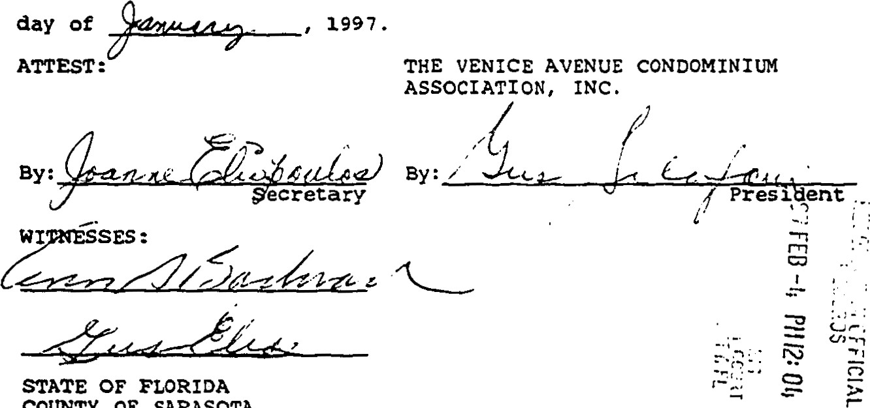

COUNTY

OF

SARASOTA

1 HEREBY CERTIFY that on this day before me, a Notary

Public in an for t St te pf Florida at large, personally peared as President and as secretary, THE VENICE

ONDOMIN1cn4 socl TION, INC. , and they acknowledged they are such officers of said corporation; and foregoing Certificate of Amendment to the corporation, and affixed thereto the corporation; that they are authorized to execute said of Amendment to the Bylaws and that free act and deed of said corporation. They are to me or have produced their driver's licenses and did not take an oath.

WITNESS my handend offic •al seal at Venice, day of

My Commission Expires :

CERTIFICATE OF AMENDMENT

TO THE

DECLARATION OF CONDOMINIUM

VENICE CONPOMTN1tJM. a Condominium

THE VENICE AVENUE CONDOMINIUM ASSOCIATION, INC. . its address being 512 West Venice Avenue, Venice, FL 34285, Sarasota County, by the hands of the undersigned hereby certify that:

The Declaration of condominium of VENICE AVENUE CONDOMINIOM, a Condominium is recorded in O. R. Book 1282, page 129, of the Public Records of Sarasota County , Florida . The following amendments to the Declaration of Condominium were submitted to the entire membership of the Association at its meeting called and held on the 4th day of January, 1997, and approved by affirmative vote of of the voting interests present and voting at a meeting at which a quorum is present, as required by the Declaration of Condominium.

Article WII, Section A(l), is hereby amended to read as follows:

1. No apartment shall be used for any purposes other than residential. No apartment may be perma— nently divided or subdivided into a smaller unit nor any portion thereof sold or otherwise trans— ferred without amending this Declaration of condo— xninium to show the changes in the apartment units Text, letter

   Description automatically generatedto be affected thereby.
2. Article WII, Section A (10) , is hereby amended to read as follows:

No more than two persons shal I reside in onebedroom a part.ment : no more than four versons in wp—bedroom or six persons in a three— bedroom

STATE OF FLORIDA cotTNTY OF SARASOTA

1 HEREBY CERTIFY that on this day before me, a Notary

Public in and for the S ate of Florida at large, personal Iy eared as President and as secretary, of THE VENICE AVENUE C NDO INI ASSOCIATI INC. and they acknowledged before me that they are such officers of said corporation; and they executed the foregoing Certificate of Amendment to the Declaration of Condominium on behalf of said corporat ion, and affixed thereto the corporate seal of said corporation; that they are authorized to execute said Certificate of Amendment to the Declaration of Condominium and that the execution thereof is the free act and deed of said corporation. They are personally known to me or have produced their driver's licenses as identification and did not take an oath.

WITNESS my hand and offic •al seal at Venice, Sarasota County, Florida this a.R_e_ day

OFFICIAL RECORDS

2øø2ø239112002023911 2 PGS

2002 FEB 12 09:57 AM

CERTIFICATE OF AMENDMENT KAREN E. RUSHING

CLERK OF CIRCUIT CURT

TO THE *ASOTA COUNTY

CBETHEL Receipt#135699 DECLARATION OF CONDOMINIT-M

OF

VENICE qondominiun

Venice Avenue Apartments condominium Association, Inc. , its address being 512 Venice Avenue W. , *703, Venice, FL 34285, Sarasota county, by the hands of the undersigned hereby certify

that :

The Declaration of condominium of THE VENICE AVENUE CONDOMINIUM, a condominium is recorded in O, R. Book 1282, page 129, et seq. , as amended, of the Public Records of Sarasota County ,

Florida. The following amendment to the Declaration of Condominium

was submitted to the entire membership of the Association at its meeting called and held on the day of January, 2002, and

approved by affirmative vote of not less than 75% of the unit owners present and voting at a properly called members' meeting at which a quorum was present, as required by the Declaration of

Condominium.

Article IX Administration by condominium Association, by

adding paragraph (F) , is hereby amended to read as follows : (F) Alteration and Improvements ot Common

|  |  |  |  |
| --- | --- | --- | --- |
| Elements . | There | be no m#erial |  |

ation. substantial additions or turtber im— provement of common limited common elements or to property which Aseocia— tion propertv. either bv owners or the Association. without prior approv41 of the Board of Directors ot the Association. There shall be no change in the shares and rights of a Unit Owner in the common elements which are altered or further ÄpproveA.

IN WITNESS WHEREOF, said Association has caused this

Certificate to be signed in its name by its president, this \ \+



2002 •

ATTEsT: VENICE AVENUE APARTMENTS

CONDOMINIUM ASSOCIATION, INC.

|  |  |  |
| --- | --- | --- |
|  |  |  |
| CHARLES K. THA | | IR, |

PresTdent

WITNESSES :

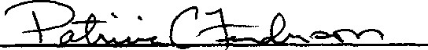

1

2002023911 2 

STATE OF FLORIDA

COUNTY OF SARASOTA

1 HEREBY CERTIFY that on this day before me, a Notary Public in and for the State of Florida at large, personally appeared CHARLES K. THAYER, as President and NANCY WATERMAN, as secretary, of VENICE AVENUE APARTMENTS CONDOMINIUM ASSOCIATION, INC. , and they acknowledged before me that they are such officers of said corporation; and they executed the foregoing Certificate of Amendment to the Declaration of Condominium on behalf of said corporation, and aff ixed thereto the corporate seal of said corporation; that they are authorized to execute said certificate of Amendment to the Declaration of Condominium and that the execution thereof is the free act and deed of said corporation. They are personally known to me or have produced their driver licenses as identification and did not take an oath.

WITNESS my hand and official seal at Venice, Sarasota County, Florida this  day Of  2002.



Printed Name of Notary:

PATRICIA C. FENDERSON

Notary Public Commission 

My Commission Expires :

1

CERTIFICATE OF AMENDMENT

DECLARATION OF CONDOMINIUM 2øøS271491

THE VENICE AVENUE CONDOMINIUM

VENICE AVENUE CONDOMINIUM ASSOCIATION, INC., its address being 512 Venice Avenue W. , #503, Venice, FL 34285, Sarasota County, by the hands of the undersigned hereby certify that:

The Declaration of Condominium of THE VENICE AVENUE CONDOMINIUM is recorded in O. R. Book 1282, page 129, of the Public Records of Sarasota County, Florida . The following amendment to the Declaration of Condominium was submitted to the entire membership of the Association at its meeting called and held on the

21st day of October 2005 and aoproved by affi rmative vote of not less than 75% of the unit owners present, in person or by proxy, at a properly called members' meeting at which a quorum is present, as required by the Declaration of Condominium.

Article 17, Restrictions, paragraph A, subparagraph 13, is hereby amended to read as follows:

A. The use of the property as a condominium shall be in accordance with the following provisions :

Units may be rented or leased only after the Unit Owner has held record title to the Unit for at least one (1) year. Prior to leas inq or rent inq the Unit, the Unit Owner must obtain written approval by the Association, as provided for in Article 13 of this Declara— t ion. Entire Units only may be rented. No Unit may be subdivided and partially rented.

Unit occupancy shall on Iv be by the lessee,

1

his family and quests. Units may not be leased or rented for a term of less than three consecutive months.

IN WITNESS WHEREOF, said Association has caused this Certificate to be signed in its name by its President, this _3_

2005 .

ATTEST : VENICE AVENUE CONDOMINIUM ASSOCIATION, INC.

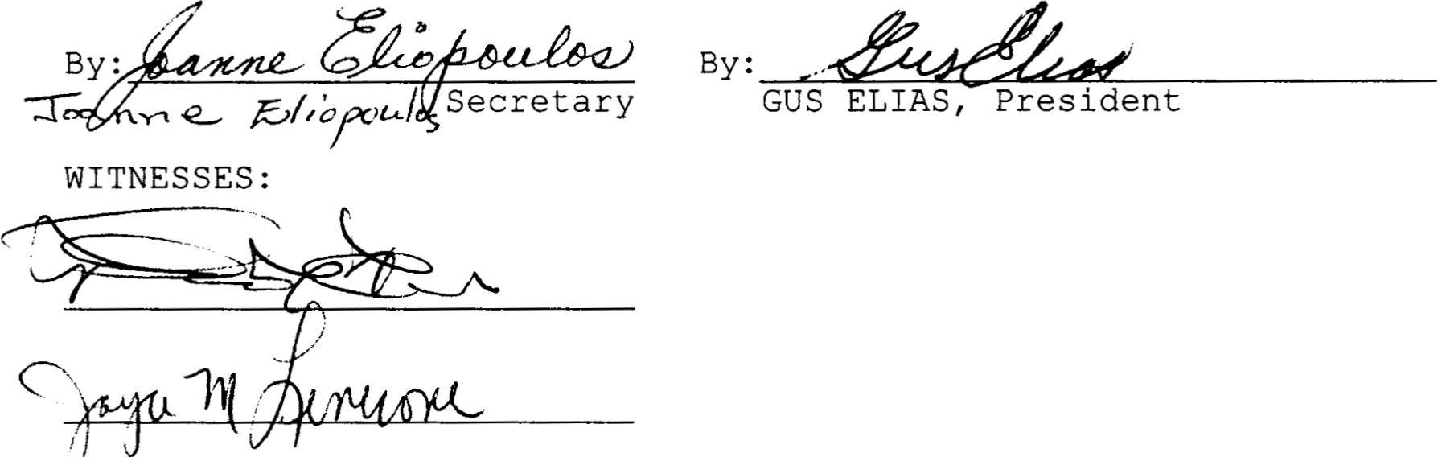

STATE

OF

FLORIDA

COUNTY OF SARASOTA

|  |
| --- |
| Joanne EX |

1 HEREBY CERTIFY that on this day before me, a Notary Public in and for the State of Florida at large, personally appeared GUS ELIAS, as President and as Secretary, of VENICE AVENUE CONDOMINIUM ASSOCIATION, INC., and they acknowledged before me that they are such officers of said corporation; and they executed the foregoing Certificate of Amendment to the Declaration of Condominium on behalf of said corporation, and affixed thereto the corporate seal of said corporation; that they are authorized to execute said Certificate of Amendment to the Declaration of Condominium and that the execution thereof is the free act and deed of said corporation. They are personally known to me or have produced their driver' s licenses as identification and did not take an oath.

WITNESS my hand and official seal at Venice, Sarasota County, Florida this g day  2005 .

My Commission Expires:

eyn;lna O Grady

Commixsaon # DD86890 x:nresFeb25.2006 Thru



ß0üde,'i

•c Bonding co.. Inc.

cad 2

HIS INSTRUMENT PREPARED BY

Robert L. Moore, Esquire Kanetsky, Moore & DeBoer, P.O. Box 1767

227 Nokomis Avenue S.

Venice, FL 34284-1767

S.S.

RECORDED IN OFFICIAL RECORDS

INSTRUMENT # 2009052320 2

2009 MAY 01 02:01 PM

KAREN E. RUSHING

CLERK OF THE CIRCUIT COURT SARASOTA COUNTY

DDAUGHER Receipt#1159432

CERTIFICATE OF AMENDMENT

TO THE

DECLARATION OF CONDOMINIUM

OF

THE VENICE AVENUE CONDOMINIUM

VENICE AVENUE CONDOMINIUM ASSOCIATION, INC. , its address being 512 Venice Avenue W. , #503, Venice, FL 34285, Sarasota County, by the hands of the undersigned hereby certify that:

The Declaration of Condominium of THE VENICE AVENUE CONDOMINIUM is recorded in O. R. Book 1282, page 129, of the Public Records of Sarasota County, Florida . The following amendment to the Declaration of Condominium was submitted to the entire membership of the Association at its meeting called and held at 10: 00 a.m. on the 10 th day of January, 2009, and approved by affirmative vote of not less than 75% of the unit owners present, in person or by proxy, as required by the Declaration of Condominium.

Article XVII, Restrictions, paragraph A, by adding paragraph 14 to read as follows:

A. The use of the property as a condominium shall be in

accordance with the following provisions:

14 . To minimize noise within THE VENICE AVENUE CONDOMINIUM building, sound abatement shall be used with all floor coverings on the interior of all condominium units except those on the first floor. The application shall be as follows: Floor coverinqs in each unit shall consist of heavy carpetinq with a minimum 6 pound inch pad or 90 ounce cushion or equivalent under said carpeting throughout the unit except that other floor inq surfaces may be placed in the bathrooms, the kitchen and the entry hall where there are dropped ceilings, providing it has a minimum 1/4 inch cork or a sound abatement mat underlayment and complies with all other provisions of the Association documents. Units presently with tile or other hard surfaces are qrand—fathered and may be repaired. If

1

or other hard surfaces are grand—fathered and may be repaired. If entirely replaced, they shall have proper underlayment as outlined above .

The provisions and penalties as outlined in the State of Florida Statutes, Chapter 718 of the Condominium Act and the Rules and Requlations of the Association shall apply to enforcement of this provision.

IN WITNESS WHEREOF, said Association has caused this

day of April, 2009.

ATTEST : VENICE AVENUE CONDOMINIUM

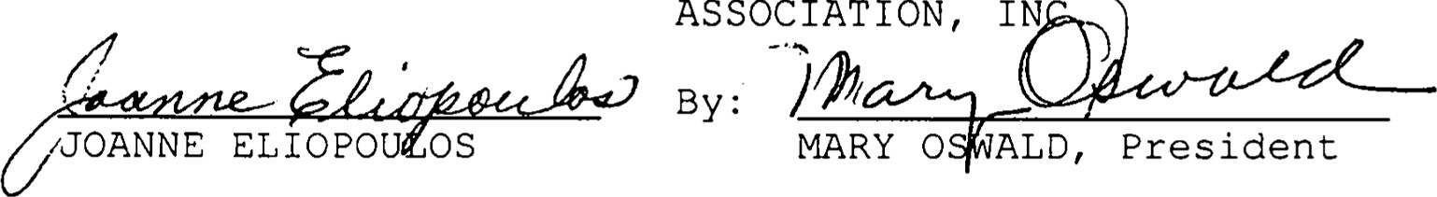

By:

WITNE SES:

STATE OF FLORIDA

COUNTY OF SARASOTA

I HEREBY CERTIFY that on this day before me, a Notary Public in and for the State of Florida at large, personally appeared, MARY OSWALD, as President and, JOANNE ELIOPOULOS, as Secretary, of VENICE AVENUE CONDOMINIUM ASSOCIATION, INC. , and they acknowledged before me that they are such officers of said corporation; and they executed the foregoing Certificate of Amendment to the Declaration of Condominium on behalf of said corporation, and affixed thereto the corporate seal of said corporation; that they are authorized to execute said Certificate of Amendment to the Declaration of Condominium and that the execution thereof is the free act and deed of said corporation. They are personally known to me or have produced their driver' s licenses as identification and did not take an oath.

WITNESS my hand and official seal at Venice, Sarasota

day of April, 2009.

My Commission Expires: u/.3//La/8

RLM\jw\veniceavenue.cad 2

94050049

INSTRUMENT PREPARED BY

SHARON S. VANDER WULP

CERTIFICATE BOX VENICE.

TO THE

DECLARATION OF CONDOMINIUM

OF

VENICE hVENVE CONDOMINIUM. h CONDOMINIUM

VENICE AVENUE CONDOMINIUM ASSOCIATION, INc. , its being 512 W. Venice Avenue, #208, Venice, FL 34285, Sarasota

County, by the handg of the undersigned hereby certify

The Declaration of condominium of VENICE AVENUE

CONDOMINIUM, A CONDOMINIUM, is recorded in O.k. Book 1282, page 129, of the Public Records of Sarasota County, Florida. The following amendments to the Declaration of condominium were submitted to the entire membership of the Association ae its meeting called and held on the 31st day of March, 1994, and approved by aff irmative vote in excess of 75 percent (75%) of the membership present and voting at a membership meeting as required by the Declaration of condominium.

Article WII, Restrictions, Section (A) (i 1) is hereby amended read as Euiiøss;

(A) The use of the property as a condominium shall be In accordance with the following provisions:

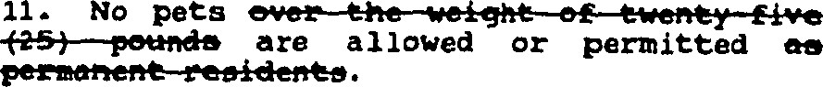

IN WITNESS WHEREOF, said Association has cauaed thie

Certificate eo be signed in its name by its President, this

1994 .

AmEST: VENICE AVENUE CONDOMINIUM ASSOCIATION, INC. By •—-.

WITNESSES :

1

STATE OF

COUNTY OP SARASOTA

I HEREBY CERTIFY that on this day before me, a Notary Public in and for the State oz Florida at large, personally appeared ROBERT O. BRUNELLE, as President and JOANNE ELIOPOUIDS, as secretary, of VENICE AVENUE CONDOMINIUM ASSOCIATION. INC. , and they acknowledged before me that they are such officers of said corporaeion; and they executed the foregoing Certificate oz Amendment of Declaration of Condominium on behalf of said corpora— tion, and affixed thereto the corporate seal of said corporation ; that they are authorized to execute said Certificate of Amendment to the Declaration of Condominium and that the execution thereof is the free act and deed of said corporation. They are personally known to me or have produced their driver's licenses ae identification and did not take an oath.

WITNESS my hand and official Beal at Venice, Sarasota County, Florida this J} day Of  1994 .

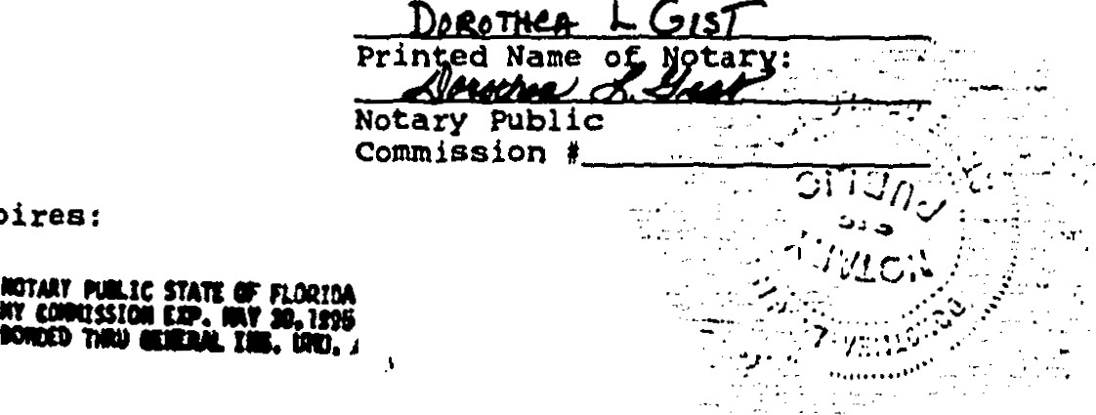

L

Ges7¯

My

Commission

Expiree:

SVW/car/Venice . cad

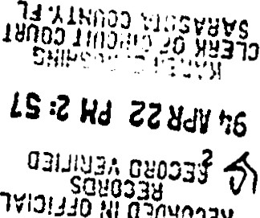

N'

02CY0028

OF AMENDMENT ATTORNEY AT LAW P.O.

AMENDMENT TO THE

BY-LAWS OF THE

VENICE AVENUE CONDOMINIUM ASSOCIATION, INC.

Paragraph 1, Article I l , Members' Meetings, of the By-Laws of

VENICE AVENUE CONDOMINIUM ASSOCIATION, INC. , recorded in Sarasota

County, Florida, in 0. R. Book 1282, page 165, is amended as follows:

1. Annual Members I Meetings: The annual members' meeting shal l be held at the office of the corporation at 10:00 a.m. , Eastern

Standard Time, on the second (2nd) Menday Saturday in January of each year for the purpose of electing Directors and transacting any other business authorized to be transacted by the members; provided, however,

if that day is a legal holiday, the meeting shall be held at the same

 ceo hour on the next day that is not a hol iday.

CERTIFICATE OF AMENDMENT 947667

TO

THE VENICE AVENUE CONDOMINIUM

THE UNDERSIGNED, PRESIDENT of THE VENICE AVENUE CONDOMINIUM ASSOCIATION, INC . , a Florida non-profit corporation, hereby certifies that the attached amendment was duly adopted by said Association, amending the By-Laws of THE

VENICE AVENUE CONDOMINIUM, filed in Sarasota County, Florida, in o.R. Book 1282, Page 165.

VENICE AVENUE CONDOMINIUM ASSOCIATION, INC.

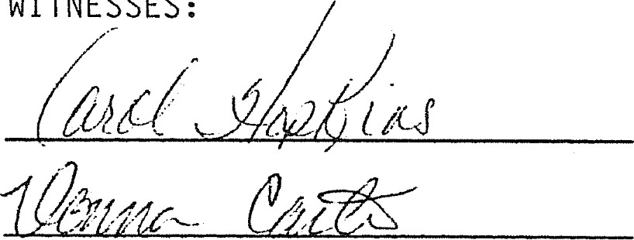

WITNESSES:

BY

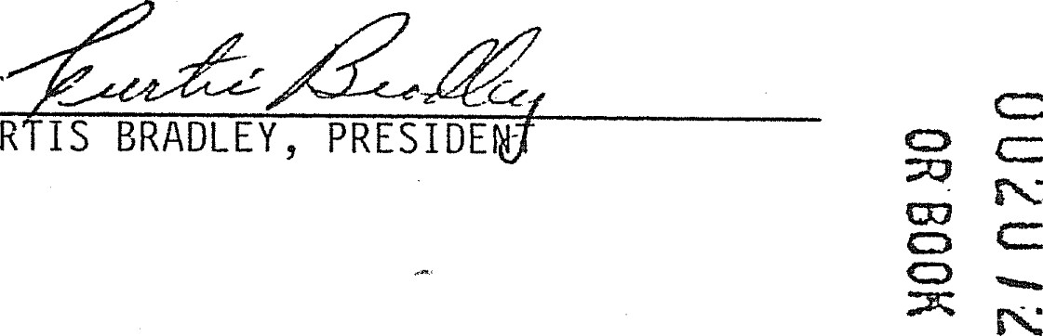

CURTIS

•State of"FÄorida Cö'å'tity of Sarasota )

c

I hereby certify that on this 24th day of0ctober ,A.D . 1988, before me personal ly appeared Curtis Bradley and Lois E. Thomas, President and

Secretary respectively, of THE VENICE AVENUE CONDOMINIUM ASSOCIATION, INC. , a corporation under the laws of the State of Florida, to me known to be the persons described in and who executed the foregoing Certificate of Amendment and severally acknowledged the execution thereof to be their free act and deed as such officers, for the uses and purposes therein mentioned; and the said instrument is the act and deed of said corporation.

WITNESS my signature and offici al seal at C&S Bank in the County

of Sarasota and State of Florida, the day and year last

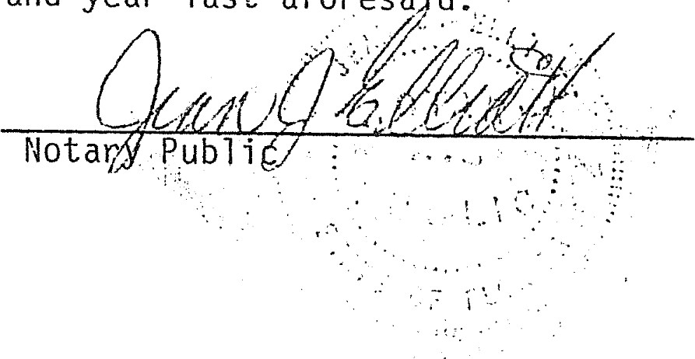

aforesaid.

My Commission Expires: 

NOTARY PUBLIC, STATE OF FLORIDA';

MY COMMISSION EXPIRES: JULY 29, 199f.

BONDED THRU NOTARY PUBLIC UNDERWRITERS.